1. 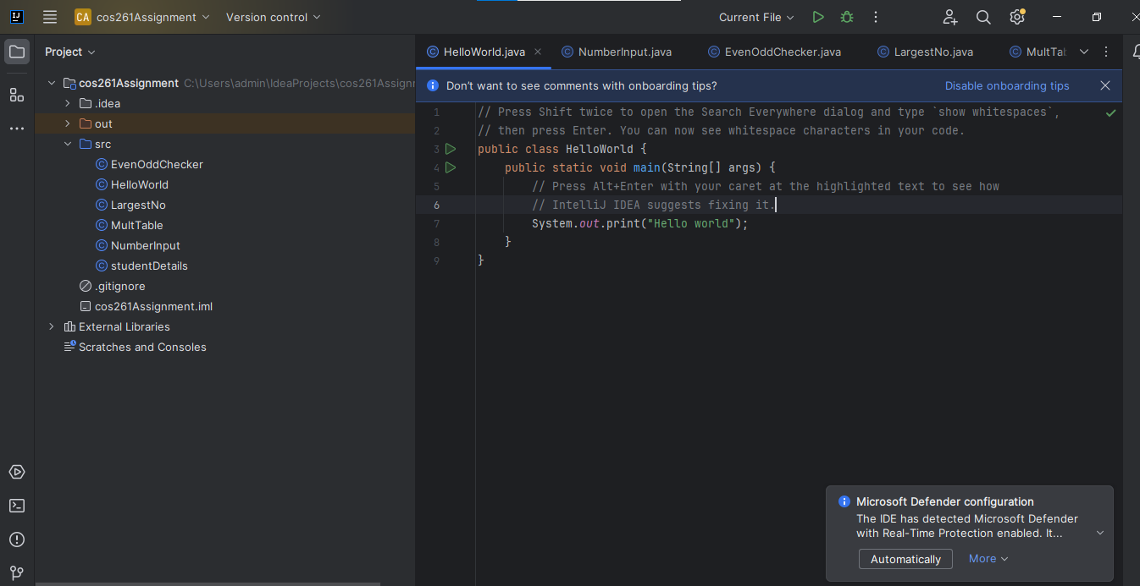

1. = = is different from .equals() mainly because == refers to the address in memory while the .equals() method refers to the object itself.
2. The main method is used as the entry point for the execution of the code. It is recognized by the JVM as the starting point of the code itself.

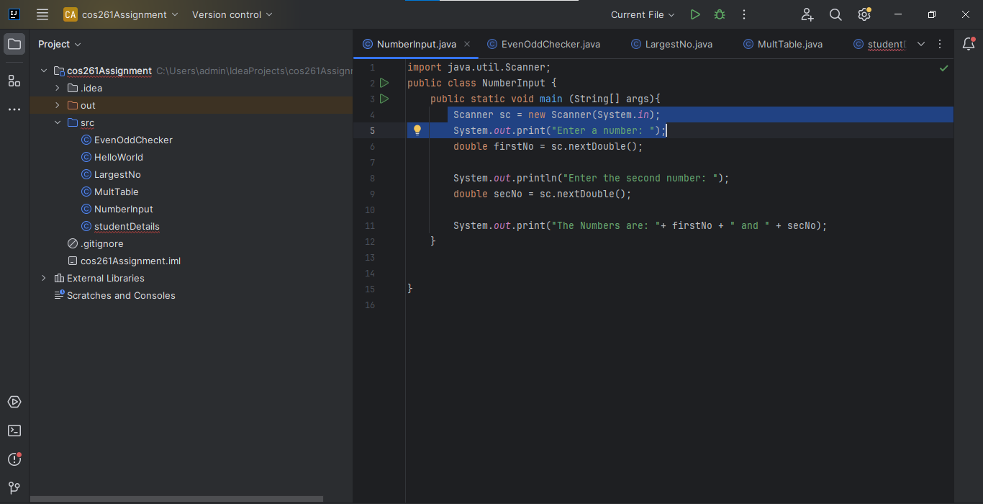

1. Integers are numerical figures while strings are characters int is a primitive type while Integer is a class (wrapper class)

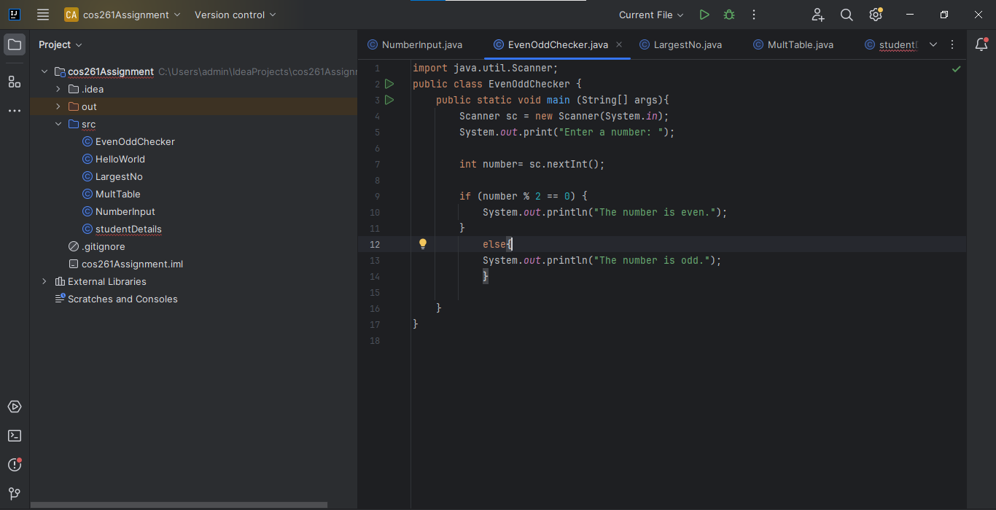

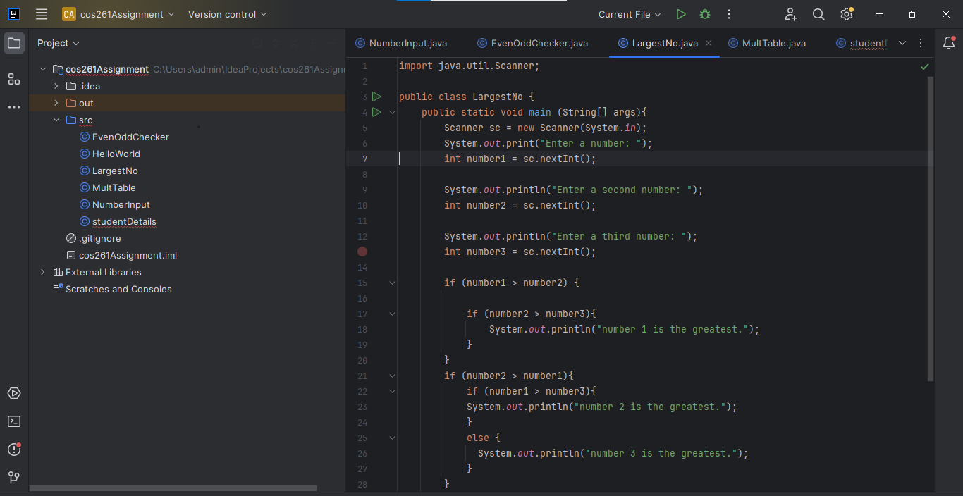

1. While loops are used for dynamic conditions, for loop is used when the number of iterations are known, and do while loop always runs at least once; even if the condition is initially false.

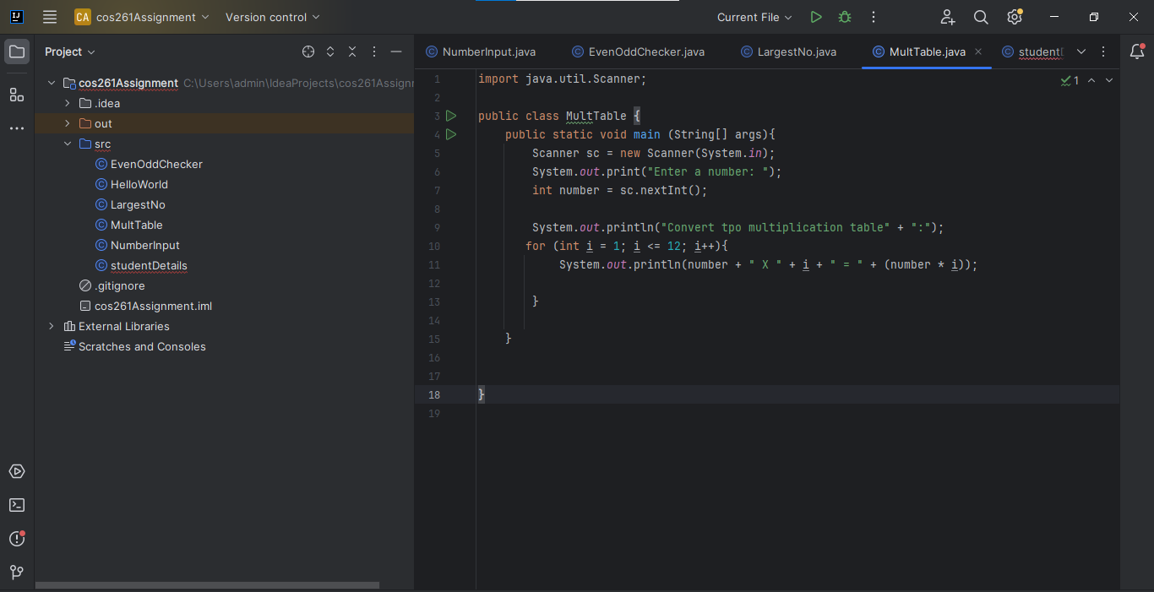

1. The 4 pillars of OOP in java are: encapsulation, abstraction, inheritance and polymorphism.
2. Method overloading occurs when a class has more than one method with the same name but different parameters.
3. Writing clean code means writing code that is easy to read, understand and maintain.

Characterstics of clean code:

Use comments

Keep methods short and focused

Use meaningful names.